**Assignment 2**

**Que 1:**

**import java. util. Scanner;**

//The above statement will import scanner class

**public class PowerMath {**

**public static void main (String [] args) {**

**int A=1, b=2, pow;**

**Scanner input=new Scanner (System.in);**

/*The above statement will create new instance variable of

scanner class and it will take inputs from console */

**pow=(int)Math.pow(A,b);**

/* The above formula will give the value of A to the power of b

and (int) means the answer would be in integer. */

**System.out.println("A \t b \t pow(A,b)");**

**System.out.println(+ A+" \t "+ b+ "\t " + pow);**

**A = A + 1;**

**b = b + 1;**

//The above two statements will increase the value of A and b by 1

**pow=(int)Math.pow (A, b);**

**System.out.println(+ A+" \t "+ b+ "\t " + pow);**

**A = A + 1;**

**b = b + 1;**

**pow=(int)Math.pow (A, b);**

**System.out.println(+ A+" \t "+ b+ "\t " + pow);**

**}**

**}**

**Output:**

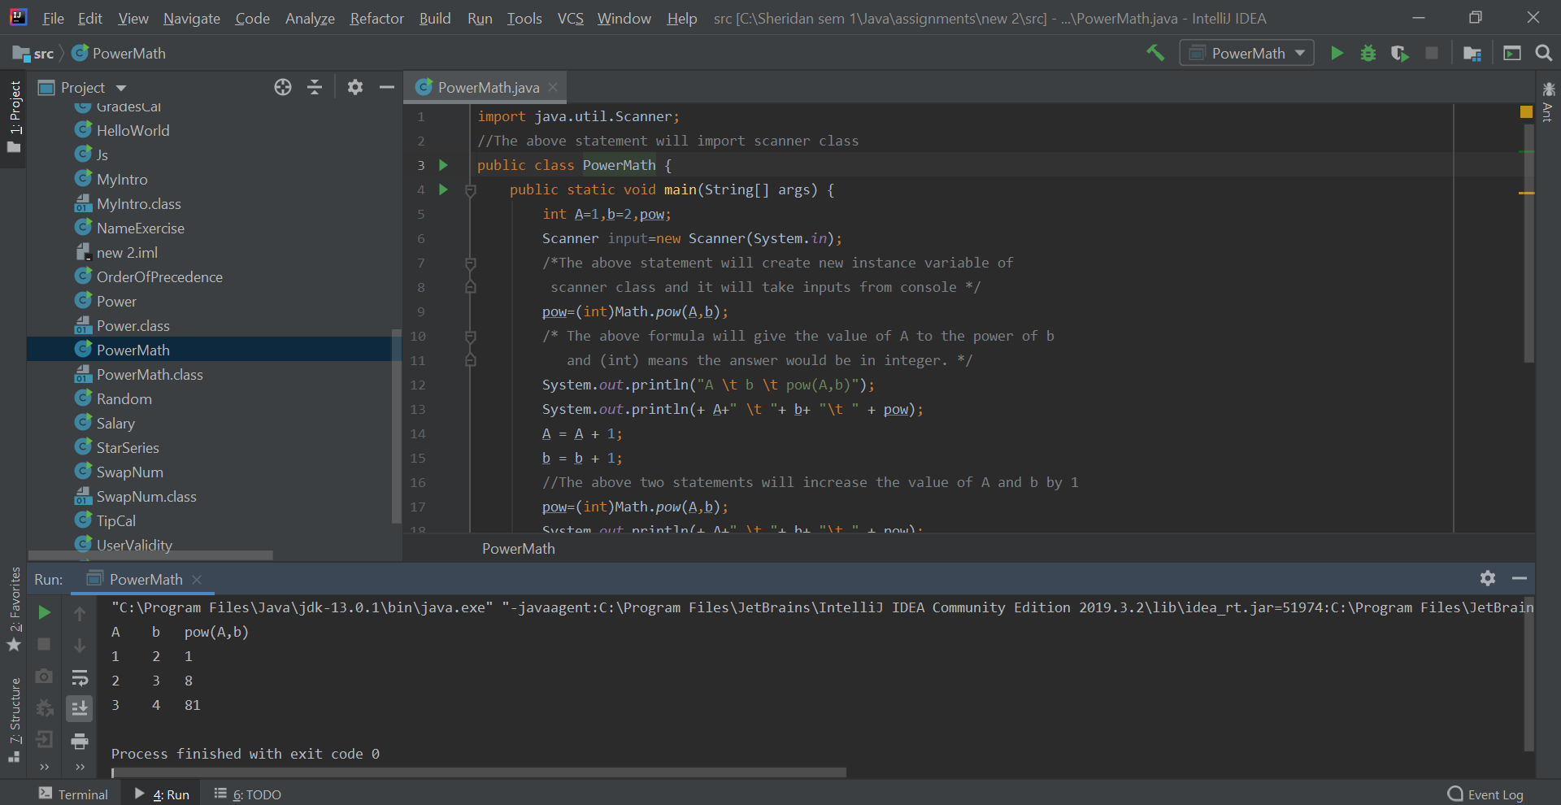

**Que 2:**

**import java.util.Scanner;**//The above statement will import scanner class **public class FlipCoin {  
 public static void main(String[] args) {  
 String head,coin,tail;** //String class names **Scanner input=new Scanner(System.*in*);** /*The above statement will create new instance variable of  
 scanner class and it will take inputs from console */ **System.*out*.println("Head or Tail ??");  
 coin=input.next();** /* In the above statements System.out.println will print the  
 words written in brackets while the another statement  
 (coin=input.next();) will take input from user .*/ **int flipCoin=(int)Math.*rint*(Math.*random*());** /* The above formula(Math.random) will generate any number  
 between o and 1.Another function(Math.rint) will round of the value in integer.*/  
 **String res=(flipCoin==0)? "head":"tail";** /* The above statement will give compare the flipCoin result  
 if its 0 then it will give head otherwise it will give tail.*/  
 **if(coin.equalsIgnoreCase(res)) {  
 System.*out*.println("You Win");  
 }  
 else {  
 System.*out*.println("Better Luck Next Time");  
 }**  /* The above statements will compare coin and res. If both are  
 equal(Ignoring case) then it will give first statement else it will  
 give another statement*/  
 **}  
}**

**Output:**

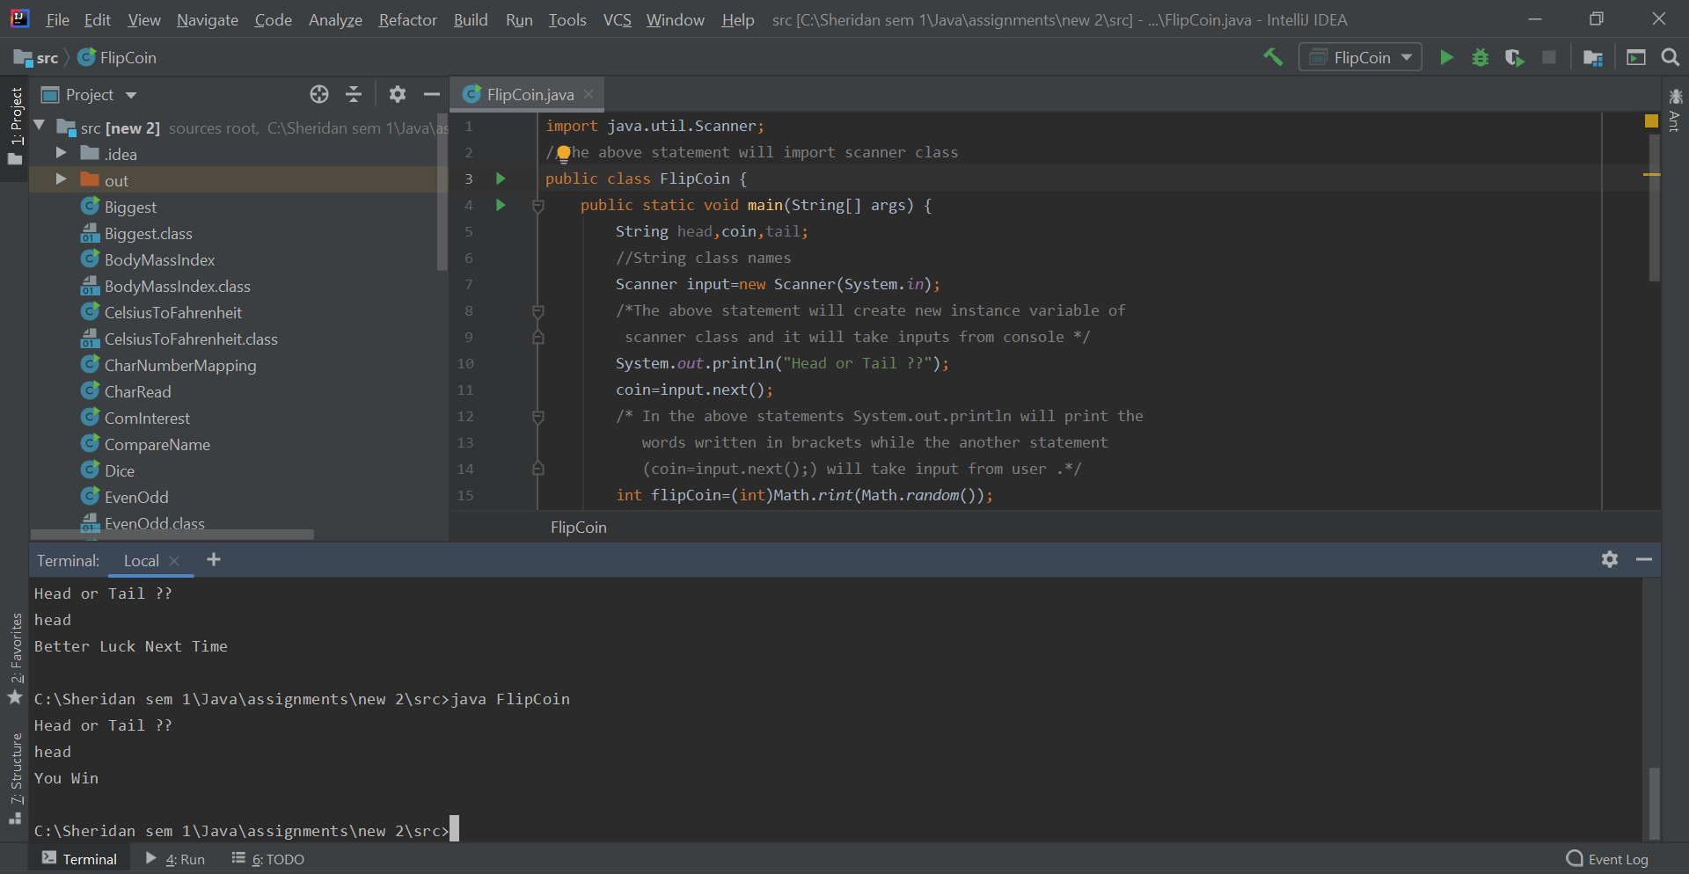

**Que 3:**

**import java.util.Scanner;**//The above statement will import scanner class **public class BodyMassIndex {  
 public static void main(String[] args) {  
 Double htFt,htInches,height,weight,BMI;  
 Scanner in=new Scanner(System.*in*);** /* The above statement will create new instance variable of  
 scanner class and it will take inputs from console */ **System.*out*.println("Enter your Height in ft and/or in inches");  
 htFt=in.nextDouble();  
 htInches=in.nextDouble();** /*In the above statements System.out.println will print the  
 words written in brackets while the another statements  
 (htFt=input.nextDouble(); And htInches=input.nextDouble();)  
 will take inputs from user .*/ **height= (htFt)*12 + htInches;** /* The above formula will convert feet into inches and  
 give total height in inches at last.*/ **System.*out*.println("Enter weight in pounds(lb)");  
 weight=in.nextDouble();  
 BMI = (weight/(height*height))*703;** // The above formula will calculate the body mass index **System.*out*.println("Your BMI figure is " + BMI);  
 System.*out*.println("BMI \t \t \t \t \t BMI Category");  
 System.*out*.println("Less than 15 \t \t \t Very severely underweight");  
 System.*out*.println("Between 15 and 16 \t \t Severely underweight");  
 System.*out*.println("Between 16 and 18.5 \t Underweight");  
 System.*out*.println("Between 18.5 and 25 \t Normal(healthy weight)");  
 System.*out*.println("Between 25 and 30 \t \t Overweight");  
 System.*out*.println("Between 30 and 35 \t \t Moderately obese");  
 System.*out*.println("Between 35 and 40 \t \t Severely obese ");  
 System.*out*.println("Over 40 \t \t \t \t Very severely obese");  
 }  
}**

**Output:**

